HIST 374 (Q-36911) WI –AFRICA AND THE ATLANTIC SLAVE TRADE
York College, City University of New York
Department of History, Philosophy, and Anthropology, Interdisciplinary Studies, Cultural Diversity, and Black Studies Programs

Mode of Instruction (zoom online lectures / BlackBoard discussion)
T/TH 3:30PM – 4:45PM / Fall 2020

Professor Oluremi “Remi” Alapo.
Tel: see course instructor contact section on BB; Email: oalapo1@york.cuny.edu

Office Hours: via zoom every Tuesday and Thursday: 5PM – 630PM

*Syllabus Tentative and Subject to Change

Prerequisites and/or Co-requisites

(3 hrs.: 3 cr. Pre req: English 125 and 3 credits of History)

COURSE DESCRIPTION

A study of the political, economic, social, and demographic challenges confronting Africa during the era of the Atlantic Slave Trade (15th-19th centuries). The course will conclude with a CTLET approved OER / ZTC Active Learning Assignment. The course includes an opportunity to receive a certificate of recognition from the International Human Rights Commission (IHRC).

COURSE OBJECTIVES

Students will be able to:

  - Describe pre-colonial African states and societies
  - Analyze the relationship between Africans and Europeans
  - Understand the origins, nature, growth, and effects of the Atlantic slave trade
  - Evaluate the causes and effects of the abolition of the Atlantic slave trade

OER COURSE NARRATIVE

In addition to the course objectives outlined above, the OER / ZTC learning materials will include a compilation of resources that will analyze the historical development of one or more non-U.S. societies (Africa) and the significance of one or more recent major movements that have shaped that society. Other topics will include Trade and Commerce in Africa from 1500 – present, African History and Culture before the Trans Atlantic Slave Trade, Africa's relationship to the diaspora including both continental Africans living in the diaspora and people of African Descent in the Americas. The OER that students will be involved in will be an additional assignment on 1619 – 2019. This period in history, which is absent from most higher education curriculum recognizes 400 years of the beginning of the Trans - Atlantic slavery in the Americas and 400 years later marking the “Year of Return”. The need to conduct additional research and bring into lime light the many contributions of Africa, Africans and People of African Descent during these period as well as the many trails and travails of the afore mentioned people around the world in the 21st century 400 years after the first set of Africans arrived in Jamestown, VA is of utmost importance in world history.

The other rationale behind designating this course as an OER / ZTC is that most current course textbooks are very expensive for many students to afford leaving them to miss turning assignments in, not come to class or participate in class discussions. The instructor will supplement all course requirements with the following OER / ZTC learning resources below which will also be posted on each week’s discussion folder on Black Board. The learning resources are provided FREE of charge to students to enhance their learning and will include a list of selected readings from journals, periodicals, links from history web resources and specific documents such as the "HR Bill 40 - The African Americans Bill" on reparations, restorative justice and human rights. Additional resources on African History and Diaspora Studies as they relate specifically to the Trans - Atlantic Slave trade and its current day continuous systematic racism and its traumatic effects in the lives of black peoples around the world which are usually not richly elaborated in many textbooks or in the curriculum when the history of Africa or people of African descent is being discussed.

OER / ZTC CTLET PROJECT DESCRIPTION

Active Learning Assignment – to create a compilation of LEARNING RESOURCES based on the syllabus weekly topic and course assignments requirements that can be added to by students (and other faculty). These learning resources will be housed or uploaded on CUNY Academy Commons website after the compilation by students and the instructor at the end of the Fall 2020 semester. Students will research appropriate learning resources pertaining to each week’s topic and compile information such as videos, articles, books, web links, from various sources. The learning resources that students will compile will be incorporated into the syllabus as “additional learning resources”.

The Active Learning Assignment that students will be responsible for will be an assignment on the discussion of 1619 – 2019, recognizing 400 years of slavery and its effects on Africa, Africans and People of African Descent; recognizing the “African American Experience” and the need for additional educational and access to appropriate resources that will enable Africans and people of African Descent to document, continue to conduct research, and include in higher education curriculum information on 400 years of activities surrounding the Year of Return for People of African Descent, back to Africa initiatives, or in seeking justice and human rights recourse for the socio, economic and political historical injustices that have perpetuated the day to day lives of people of African descent for more than 400 years. This is a writing intensive (WI) course but designed to be fun at the same time to actively engage student in research and to peek their curiosity in learning about African, Afro - Caribbean and Afro American History or the Black Experience in the Americas.

There will be guest lectures / presentations by the International Human Rights Commission (IHRC) and by African scholars well versed in the areas of the course topic. Students will have the option to receive a certificate in Human Rights based on a pilot project by the IHRC and incorporate a human Rights component to their final exam project based on the guidelines set by the IHRC in conjunction with the objectives of the OER /ZTC course syllabus. Overall, the expected goal for the HIST 374 active learning assignment will be to create and add to educational resources periodically through the creation of a collective work of annotated bibliographies and an individual presentation. Students will start from the beginning of the semester by writing reflection papers, responding to discussion questions posted by the instructor, and interacting with other students, commenting on their posted discussion questions on BB where they will start building on their compilation of annotated bibliographies and other resources. Students will also be invited to contribute to the CUNY Academic Commons page where the OER / ZTC project for HIST 374 will be housed at the end of the Fall 2020 semester. The active learning assignment is intended to be a fun and engaging semester project.

Grading for HIST 374 OER / ZTC course will be 100 points based on a WI course requirement as follows:
• Reflection papers: (4 of them / once per month, 2 pages each) – 20 points
• Participation (weekly discussion questions, responses to others post on BB and outline of final research paper) - 20 points.
• Midterm: (intro and background info to final paper) - 20 points
• Response / Reaction paper: (response or react to a select topic of interest as part of the final research paper) - 20 points.
• Final Exam: (recommendations, solution and conclusion of the research paper, a presentation: story map / voice thread or ppt presentation and mp4 voice summary) – 20 points.

College policy requires that the grade of “Absent” or “Incomplete can only be given if there is written documentation of emergency situations. Students must confer with the instructor to arrange a specific date by which the assignments and/or exams will be completed, which must be at least one week in advance of the deadline set by the office of the Registrar.

This course has been designated as an OER / ZTC course. All required reading and learning resources below are also posted on each week’s discussion folder on BB.
It is assumed that a majority of the students enrolled in this course will be upper - level history majors. Students interested in purchasing course texts will be provided a list of recommended resources that they may purchase to add to their personal library collection even though no course text is required for HIST 374.
WEEK 1 [8/26 - 8/30]: Introduction to Africa before 1500 / Syllabus Review
OER / ZTC resources:
Suggested Reading
N/A

Videos
- (Africa before 1500 - 21 minutes) - The World: A Television History #15 Africa Before The Europeans - YouTube

- (What were Africans doing in 1492? - 13 minutes): What Were Africans Doing In 1492? - YouTube

- (10) AFRICA Episode 1 Different but Equal Written & Presented by Basil Davidson Executive Producer - YouTube

Discussion Questions / Reflection:
- Introduce yourself and share your general perspective slavery.
- Describe what you know or have learned about African history before 1500.
WEEK 2 [8/31-9/6]: Africa before 1500
Suggested OER / ZTC resources:
Readings
Resources on African Civilization before European Colonization
- (African History from 1500) - Chapter 9: African History to 1500 | World History to 1700 (lumenlearning.com)
Videos
- (10) AFRICA Episode 3 Caravans of Gold Written & Presented by Basil Davidson Executive Producer Mic - YouTube
- 5 Reasons Why The African Continent Fell - YouTube
- Nok Culture: A History Of Ancient West African Culture - YouTube
- Top 10 African Contributions To World Civilization - YouTube

Discussion Questions / Reflections:
- What Africans were doing before European contact.
- Share your reflections on what you discovered / have learned about African civilizations before 1500.
WEEK 3 [9/7-9/13]: African Civilizations Before European Contact
Suggested OER / ZTC resources:
Readings
- Section A – E on Ancient Civilizations - Africa: Ancient Civilizations | OER Commons
- Ancient Civilizations: Ancient Civilizations | OER Commons
- History of Africa: General History of Africa (unesco.org)
- Global African History Timeline: Global African History Timeline (blackpast.org)
- Africa Facts: People of Africa: PEOPLE OF AFRICA - over 20 interesting and key facts (interesting-africa-facts.com)
- Africa: People, Geography, Fact (Britanica): Africa | History, People, Countries, Map, & Facts | Britannica
Videos
  - PBS series by Henry Louis Gates, Jnr. on African Civilizations: Why we’re overdue to know the brilliance of Africa’s civilizations - YouTube
  - Great Kings and Queens of Africa - YouTube
  - Faces of Africa: Keepers Of The Ark - YouTube
  - Ancient Africa & World History: 8th Century BC - YouTube

Discussion Questions / Reflection
- Discuss some of the ancient civilizations in Africa and why they are very important in history?
- Reflect on examples from the beginnings of the Common Era to the period of European imperialism, worlds of great empires, royal courts, pastoral nomads, tribal chiefs, stone palaces, intricate art, and glorious gold that emerged; kingdoms that collapsed, and intertwined with other societies.
- Include in your discussion powerful states were built from small towns and villages and those with a great network of regional and overseas trade that was established; wars that were waged, territories and people that were seized, bought, and sold, kings that became rich, and Islam that spread across the continent.
WEEK 4 [9/14 - 9/20]: African Kingdoms and Empires
Suggested OER / ZTC resources:
Readings

N/A

Videos

- African Empires - YouTube

Lost kingdoms of Africa: Series 1 – 4

- Lost Kingdoms of Africa 1 of 4 Nubia - YouTube
- Lost Kingdoms of Africa 2 of 4 Ethiopia - YouTube
- Lost Kingdoms of Africa 3 of 4 Great Zimbabwe - YouTube
- Lost Kingdoms of Africa 4 of 4 West Africa - YouTube

Reflection / Reflection Paper: African Kingdom / Empire

Conduct a research on any ONE Kingdom or Empire that existed in Africa prior to European contact and tell us about it: the location, if the kingdom or empire still exists and in what country or region it is located in Africa today.

In your response, discuss:
- Major or key contributions of that society to the west / world.
- What the kingdom / empire was or its key contributions.
- What country or countries or country in Africa today is representative of the kingdom or empire.
- Any conflicts today in that region? How did conflicts come about to that region and why?
- Any interesting findings or discoveries such as languages, food, culture, innovation or invention or any contributions to civilization from ancient did you see in current day activity / life.
Week 5 [9/21 - 9/27]: Key Civilizations and Contributions / Commerce and Trade in Africa from 1500
Suggested OER / ZTC resources:
Reading
Commerce and Trade from 1500

- Commerce and Trade 1500 - Subsaharan Africa (saylordotorg.github.io)
- The Spread of Islam in Ancient Africa: The Spread of Islam in Ancient Africa - Ancient History Encyclopedia
Videos
Key Civilizations and Contributions

- (10) AFRICA Episode 6 The Magnificent African Cake Written Presented by Basil Davidson Executive Produ - YouTube
- Africa's Great Civilizations: Why we’re overdue to know the brilliance of Africa’s civilizations - YouTube
- African Empires: African Empires - YouTube
- Stolen Legacy of African History: stolen legacy of african history ft Asa Hilliard and Dr. Ben (Black PPL) - YouTube

Discussion Questions / Reflection

Write a personal response to the following questions below:

  - Discuss some of the key civilizations and contributions of Africa to the various regions of the world before European contact or invasion or before Columbus.
  - Why was Africa prone to European invasion?
  - Describe some of the key contributions of African to "modern civilization". What impact did this invasion have on the civilization of Africa or growth?

Reminder: Outline of final paper due this week.

WEEK 6 [9/28 - 10/4]: Coming of the Europeans
Suggested OER / ZTC resources:
Readings: N/A
Videos
- First Contact Between Europe and Africa - YouTube
- The World: A Television History #15 Africa Before The Europeans: The World: A Television History #15 Africa Before The Europeans - YouTube
- What Gods Do Africans Worship? - YouTube

Discussion Questions / Reflection

Write a reflection summary from the content of this weeks’ lecture about the “coming of the Europeans to Africa before the Trans-Atlantic Slave Trade”.

Week 7: [10/5 - 10/11]: Slavery and Slave Trade in Africa: Types of Slavery / Role of Islam
Suggested OER / ZTC resources:
Readings
- History of the African Slave Trade (thoughtco.com)
- Types of Enslavement in Africa and the World Today (thoughtco.com)
- The Role of Islam in Slavery in Africa (thoughtco.com)
- Slavery before the Trans-Atlantic Trade · African Passages, Lowcountry Adaptations · Lowcountry Digital History Initiative (cofc.edu)
- Slavery before the Trans-Atlantic Trade · African Passages, Lowcountry Adaptations · Lowcountry Digital History Initiative (cofc.edu)

Videos
- Slavery In Africa Before Europeans: BASIC NIGERIAN HISTORY #10 - YouTube
- European Transatlantic Slave Trade: BASIC NIGERIAN HISTORY #11 - YouTube
- Atlantic Slave Trade Video - YouTube

Reflection / Reaction Paper on Types of Slavery
Discussion Questions / Reflection
- Discuss some shocking facts about slave trade that many people may not know about. Give key examples.
- Why do you think most people focus on just one type of slave trade?
- Discuss other types of slavery and some of their impact on Africa before the Trans -Atlantic Slave Trade.
- Discuss what was unique about other types of slave trade?

Week 8: [10/12-10/18]: Africa and The Trans-Atlantic Slave Trade: Origins and Growth
Suggested OER / ZTC resources:

Guest lecture / presentation by Professor Oluremi Alapo and Chief Ifakunle of Oyotunji Village, S. Carolina on “The origins and growth of the Atlantic Slave Trade” (Thursday October 15, 2020).

Zoom class presentation: Oluremi Alapo's Personal Meeting Room - Zoom
Contact: About OAV - Oyotunji

Readings
- Slavery before the Trans-Atlantic Trade · African Passages, Lowcountry Adaptations · Lowcountry Digital History Initiative (cofc.edu)
- https://www.gilderlehrman.org/history-resources
- The Making of the Atlantic World: http://slaveryandremembrance.org/articles/article/?id=A0001
- The Doctrine of Discovery, 1493 | Gilder Lehrman Institute of American History
- The Trans Atlantic Slave Trade: ch20_3.pdf (sps186.org)
- Mutiny on the Amistad - HISTORY
- Pre-colonial Africa | Slavery and Remembrance

Videos
- Atlantic Slave Trade Video - YouTube

3.1 The Atlantic Slave Trade (18th c. Caribbean) - YouTube

The Atlantic Slave Trade: Crash Course World History #24 - YouTube

5 African Royals That Were Taken In The Atlantic Slave Trade - YouTube

Top 10 African Tribes Taken In The Atlantic Slave Trade - YouTube

Discussion questions
No formal question but you can write a short response on the reading / video and presentation by Chief Ifakunle this week. See zoom discussion link above for October 15, 2020.
Reminder: 1st draft of final paper due this week

Week 9 [10/19 - 10/25]: The Trans - Atlantic Slave Trade
Suggested OER / ZTC resources:

Guest speaker: Dr. Wale Ajibade, Executive Director of African Views Organization will discuss “the Trans - Atlantic Slave Trade and Africa” (Thursday October 22nd).

Zoom class presentation: Revised Lectures on the Trans-Atlantic Slave Trade - YouTube

Contact: African Views Organization: www.africanviews.org

Readings
- History of the African Slave Trade (potsdam.edu)
- Images of Enslavement and the Slave Trade: https://www.thoughtco.com/images-african-slavery-and-slave-trade-4122913
- The Atlantic Slave Trade: https://www.encyclopedia.com/history/encyclopedias-almanacs-transcripts-and-maps/atlantic-slave-trade
- Transatlantic Slave Trade | Slavery and Remembrance

Videos
- The Trans-Atlantic Slave Trade - YouTube
- The Transatlantic Slave Trade : History Documentary on the Middle Passage (Full Documentary) - YouTube

Atlantic Slave Trade Video - YouTube

Discussion Questions / Reflection paper

Write a personal reflection based on the content on this weeks’ topic, readings / videos and presentation by last and this weeks’ guest speaker.
Week 10 [10/26 - 11/1]: Effects of Trans - Atlantic Slave Trade on Africa
Suggested OER / ZTC resources:
Guest Speaker: Prof. Carl Patrick Burrowes (Thursday October 29, 2020): “A discussion on the country of Liberia” – see week 13 for more on Liberia.

Contact: Home - (patricksplace.org)

Suggested Resources from Prof. Carl Patrick Burrowes
- My book titled “Liberia & the Quest for Freedom”: (Know Your Self Press | Know Your Self Press).
- Slavery and Salvation - History Of Africa with Zeinab Badawi [Episode 17] - YouTube
- Mother Africa - History of Africa with Zeinab Badawi. A series on African History where Dr. Burrowes appeared as a historian: Mother Africa - History Of Africa with Zeinab Badawi [Episode 1] - YouTube

Readings

- U.S. Slavery: Timeline, Figures & Abolition - HISTORY
- 5 Facts About Enslavement in the Americas (thoughtco.com)
- The slave trade's effect on African societies - Implications of the slave trade for African societies - Higher History Revision - BBC Bitesize
- Slave Voyages - (database and other info documenting account of the TASD)
- General History of Africa (unesco.org) - (volume set on African History)

Videos
- The Africans: A Triple Heritage - Program 1: The Nature of a Continent - YouTube
- Africa's Great Civilizations | PBS by Henry Louis Gates
- The Untold Story Effects of the Atlantic Slave Trade in West Africa - YouTube
- Slavery and Suffering - History Of Africa with Zeinab Badawi [Episode 16] - YouTube

Reflection / Reaction Paper: The Effects of the Trans Atlantic Slave Trade on Africa

Discussion Questions / Reflection:

  - What is the Middle Passage?
  - Discuss the impact of the Trans-Atlantic Slave Trade on the continent of Africa.
  - Discuss the differences in the ways in which Islam and Christianity were used in the enslavement of Africans.
  - Describe how power and prosperity flowed to the Atlantic from Slave Colonies.

Reminder: Midterm / Intro section of final paper due this week

Week 11 [11/2 - 11/8]: African Societies in the Era of the Trans - Atlantic Slave Trade
Suggested OER / ZTC resources:
Readings: N/A; Videos: N /A
Discussion Questions / Reflection
1. How did religion, natural resources, and location each determine the prosperity of African societies?
2. What role did the Atlantic slave trade play within European competition during the colonial era?
3. Discuss how African origins were transplanted in the New World and give some examples of famous places and people in the new world with African origins which are still known or practiced / used today.

Week 12 [11/9 - 11/15]: Abolition of Slave Trade
Suggested OER / ZTC resources:

Readings

- Abolitionist Movement History | Suggested Sites | History, Facts (findhistoryhere.com)
- Timeline of the Abolitionist Movement: 1830 - 1839 (thoughtco.com)
- timeline-of-abolition-movement-1830-1839-45408 - Bing images
- frederick-douglass-abolitionist-and-advocate-45214 - Bing
- Abolitionist Pamphlet Campaign (thoughtco.com)
- Slavery in the Age of Revolutions | Slavery and Remembrance

Videos
- Slavery and Abolition in the United States - YouTube
- Abolition of Slavery and the Transatlantic Slave Trade - UN Chief - YouTube

Discussion Questions / Reflection

1) Discuss some of the abolitionists and the impact they made in the abolition of the transatlantic slave trade.
2) Discuss some ways how Africans transported in the "new world" were able to revolt and resist slavery.
3) Post a reflection summary on emancipation movements during the Trans - Atlantic Slave Trade both in Africa and in the Americas based on this weeks posted learning resources (and from your own individual research conducted outside of class discussions).

Reminder: Response / Reaction paper topic section and annotated bibliographies draft due this week.

Week 13 [11/16 - 11/ 22]: The Abolition and Impact of the Trans Atlantic Slave Trade on Africa: Repatriation (Liberia and Sierra Leone)
Suggested OER / ZTC resources:
Guest Speaker: CCLP - Coalition of Concerned Legal Professionals: "Access to Justice and Legal Recourse" on Thursday 11/19/20.

Contact: Susan Prensky, Coordinator
New York State CCLP: (212) 791-1364
Readings
- See week 10 notes with Prof. Carl Patrick Burrowes
- Liberia_Backgrounder_FINAL.doc (ictj.org)

Videos

Enslavement to Emancipation - YouTube

How Many U.S. Presidents Owned Enslaved People? - HISTORY

Discussion Questions / Reflection

- Discuss the events that led to the abolition of slaves being rerouted and resettled in Liberia and S. Leone.
- Discuss the impact of the abolition of the slave trade on African societies (in your response, discuss the current day impact of resettled former slaves on indigenous Liberians and Sierra Leoneans).
- Discuss the impact of the Trans - Atlantic Slave Trade on the Americas (in your response, you can discuss the Americas in general, a specific region such as North America, the Caribbean, Central or South America or a country).
- Share a personal reflection on emancipation movements in both Africa and the Americas during the Trans-Atlantic Slave Trade based on this weeks’ posted learning resources (and from your own personal research that you conducted outside of class discussion).

Week 14 [11/23 – 11/25 [thanksgiving break from 11/24 – 11/29]: The Trans - Atlantic Slave Trade: Africa and People of African Descent: 400 Years Later.
Suggested OER / ZTC resources:
A discussion by Professor Oluremi Alapo, course instructor for HIST 374 on Human Rights issues / Challenges.
Contact:
Adjunct Faculty, Department of History, Philosophy, and Anthropology — York College / CUNY
Adjunct Faculty, Center for Ethnic Studies – BMCC (cuny.edu) / Social Sciences Department at Borough of Manhattan Community College (BMCC), CUNY
Special Advisor to the Secretary General of IHRC / Director for Global Education, Leadership Training and Youth Development – IHRC | International Human Rights Commission Relief Fund Trust (ihrc-hq.org)
Advisory Committee Member, African Views Organization
Director, Institute for Peace and Leadership, Inc. | Research, Advocacy and Workshops on Sustainable Development Goals (SDGs) 5 on Gender Equality, Empowering women and Girls and SDG 16 on Peace and Justice
Readings
International Human Rights
IHRC | International Human Rights Commission Relief Fund Trust (ihrc-hq.org)

OHCHR | CHR United Nations Commission on Human Rights

Human Rights | United Nations

Human Rights Day 10 December (un.org)

Universal Declaration of Human Rights | United Nations

Protect Human Rights | United Nations
Human Rights Day 10 December (un.org)

New York State Human Rights

New York State Division of Human Rights | (ny.gov)
Division of Human Rights | The State of New York (ny.gov)

NYC Commission on Human Rights: Human Rights (nyc.gov)

New York City Human Rights Law: The Law - CCHR (nyc.gov)

International Decade for People of African Descent
- Slavery Remembered | Slavery and Remembrance
- Geography in the News: Trans-Atlantic Slave Trade Remembered – National Geographic Society Newsroom
- International Decade for People of African Descent | United Nations (2015 - 2024)
- Programme of Activities for the Implementation of the International Decade for People of African Descent | United Nations
- Intl Decade for People of African (A_RES_69_16_EN) - Microsoft Word - N1463579 (ohchr.org)
- OHCHR | International Decade for people of African descent
- International Decade for People of African Descent - General Assembly of the United Nations
- The Durban Declaration (document): A.CONF.211.PC.3.3 (un.org)
- Durban Review Conference, 20-24 April 2009 (un.org)

Videos

- IHRC | International Human Rights Commission Relief Fund Trust (ihrc-hq.org)
- OHCHR | CHR United Nations Commission on Human Rights
- Human Rights | United Nations
- NYC Commission on Human Rights: Human Rights (nyc.gov)
- Human Rights Day 10 December (un.org)

Reflection / Reaction Paper: “Human Rights Issues / Challenges for Africans and People of African Descent in the Americas 400 Years later”.

Discussion Questions / Reflection

- Respond to the discussion on Human Rights issues and challenges by Prof. Remi Alapo.
- Respond to the presentation on access to justice by CCLP (Coalitional of Concerned Legal Professionals) in week 13.
- What were the main arguments, points of reflection and recourse of action as they relate to the human rights challenges for Africans, and people of African descent according to the presenters?
- In your discussion for this week, include a summary on the learning resources posted above and the importance of some of these documents and activities contained in them in promoting human rights.
Reminder: Draft section of final paper on recommendations to Human Rights issues / Challenges due this week.
Week 15 [11/30 – 12/6]: “Africa and People of African Descent: 400 years later / 1619 – 2019: Year of Return back to Africa for People of African Descent”
Suggested OER / ZTC resources:
Presentation on Education and Re Writing History / Reparations by Dr. Akil Khalfani
Dr. Akil Khalfani, (Congressional Candidate, West Orange, New Jersey) and Director, Africa Institute at Essex Community College, NJ.
Zoom class lecture: Reparations! - YouTube
Pan Africanism / Reparations for Africa, Africans and People of African Descent / Bill H.R 40 (December 1, 2020).

Suggested Resources from Dr. Akil Khalfani

Movies / Documentaries: watch these movies to understand why reparations are needed

- SANKOFA - What Does the Principle of Sankofa Mean? - YouTube
- Roswood – (series) Jan. 5, 1923 - Rosewood, Fla., Destroyed by White Mob - Bing video
- Black Wall Street - Tulsa, OK - What is 'Black Wall Street'? History of the community and its massacre (cnbc.com)

Books: read these books to understand the need for traumatic healing

- My Grandmother's Hands: Racialized Trauma and the Pathway to Mending Our Hearts and Bodies by Menakem, Resmaa (9781942094470) (allbookstores.com)
- Post traumatic slave syndrome - Bing
Contact:
Home | Khalfani4USCongress (akilkhalfani.com)

Readings
OER / ZTC readings on Remembering the Trans - Atlantic Slavery
Ways of Recording African History | Essay | The Metropolitan Museum of Art | Heilbrunn Timeline of Art History (metmuseum.org)

- Telling a Transatlantic Story, Together | Slavery and Remembrance
- Many Voices, Multiple Perspectives | Slavery and Remembrance
- Atlantic Lives (meet those that experienced the Trans - Atlantic Slavery): People | Slavery and Remembrance

Active Learning Assignment: Additional Learning Resources
OER / ZTC readings on Bill H.R 40 [The African American Bill]
- Everyone Wants to Talk about Bill H.R 40 but for how long? Reparations: House Committee Explores H.R. 40 to Study - The Atlantic
- Proposal for An Africans American Act: Commission to Study Reparation Proposals for African-Americans Act (2015; 114th Congress H.R. 40) - GovTrack.us
- Bill H.R 40: Bill Track - H.R. 40 | Congressional Chronicle | C-SPAN.org (c-span.org)
- Booker Reparations Bill: Booker Reparations Bill Reaches 12 Senate Cosponsors
- The National Coalition of Blacks for Reparations in America: The National Coalition of Blacks for Reparations in America - Wikipedia
- Bill History in the Congressional Records: Congress.gov | Library of Congress
- H.R Bill is Not a Symbolic Act: H.R. 40 Is Not a Symbolic Act. It’s a Path to Restorative Justice. | ACLU of Northern CA (aclunc.org)
- Pass H.R. 40 Commission to Study Reparation Proposals for African-Americans Act: Petition · U.S. House of Representatives: Pass H.R. 40 Commission to Study Reparation Proposals for African-Americans Act · Change.org
- History of Bill H. R 40 on Reparations: History of H.R. 40 - A Bill To Address The Fundamental Injustice, Cruelty, Brutality, And Inhumanity Of Slavery In The United States And The 13 American Colonies Between 1619 And 1865 And To Establish A Commission To Study And Consider A National Apology And Proposal For Reparations For The Institution Of Slavery, Its Subsequent De Jure And De Facto Racial And Economic Discrimination Against African-Americans, And The Impact Of These Forces On Living African-Americans, To Make Recommendations To The Congress On Appropriate Remedies, And For Other Purposes; To The Committee On The Judiciary. - Content Details - HOB-2018-hr40 (govinfo.gov)

- H.R.40 - Commission to Study and Develop Reparation Proposals for African-Americans Act: H.R.40 - 116th Congress (2019-2020): Commission to Study and Develop Reparation Proposals for African-Americans Act | Congress.gov | Library of Congress

Videos
OER / ZTC Video Resources on BILL H.R 40
- H.R. 40 and the Path to Restorative Justice - H.R. 40 and the Path to Restorative Justice - YouTube
- House Hearings on Reparations: House hearing on reparations signals the issue is moving ahead - YouTube

OER / ZTC Video Resources on Reparations

- Watch live: Danny Glover, Ta-Nehisi Coates testify in House hearing about slavery reparations - YouTube
- The ACLU's Declaration on Reparations - YouTube
- What Do Slave Reparations Mean? | Velshi & Ruhle | MSNBC - YouTube
- Van Jones: Blacks have sacrificed more for this country than most - YouTube
- Inside Story - Slavery reparations: Is money the answer? - YouTube
- Race, Rights & Reparations on The Rock Newman Show - YouTube
- Reparations for Slavery and the Slave Trade: A Transnational and Comparative History - YouTube
- Congressman booed in reparations hearing - YouTube
- Reparations: A National Forum on Healing and Reconciliation - YouTube
- IMHO: Reparations & Accusations - YouTube

OER / ZTC reading resources on Reparations / Restoration / Atonement

Question 1: Should Congress apologize for the Trans - Atlantic Slave Trade? Why or Why Not?
- Congress Should Atone for Slavery: Congress must officially apologize for slavery before America can think about reparations (nbcnews.com)
- Question 2: After reading the proposal by the Commission below, do you believe that this is a comprehensive proposal or bill to justify for 400 years of African / American contributions to the United States?
Commission to Study and Develop Reparation Proposals for “African - Americans Act”
- Text / Audio: H.R.40 - 116th Congress (2019-2020): Commission to Study and Develop Reparation Proposals for African-Americans Act | Congress.gov | Library of Congress
Reparation Talks at the Democratic Primary Debate
The 2020 Democratic primary debate over reparations, explained - Vox

Video resources on Reparations / Restoration / Atonement

- Castle has apology for African role in slavery - YouTube
- THE CAPE COAST APOLOGY 2018 - YouTube
- The Senate has unanimously passed a resolution apologizing for slavery and racial segregation. The - YouTube
- Congressman Cohen's Speech on the Slavery Apology Resolution - YouTube
- Resolution Offers Apology For Enslavement And Racial Segregation Of African-Americans - YouTube
- United Nations honors victims of trans-Atlantic slave trade - YouTube

Reading resources on the year 1619 in US History
- The 1619 Project Aims to Change Middle America | RealClearPublicAffairs
- 1619: The Year That Shaped America | AMERICAN HERITAGE [The Forgotten Year in American History]
- 1619 in America: 400 years ago, Africans arrived in Virginia (usatoday.com)
- Slavery in America Didn't Start in Jamestown in 1619 | Time
- The First Africans | Historic Jamestowne
- The Misguided Focus on 1619 as the Beginning of Slavery in the U.S. Damages Our Understanding of American History | History | Smithsonian Magazine
- Key Dates in U.S. History (dummies.com)
- U.S. Slavery: Timeline, Figures & Abolition - HISTORY

Video Resources on the year 1619
- The 1619 Project details the legacy of slavery in America - YouTube
- New York Times' "1619 Project" explores legacy of slavery in America - YouTube

Video Resources on Slavery / Slave Trade Facts
- Why Did Europeans Enslave Africans? - YouTube
- The Atlantic slave trade: What too few textbooks told you - Anthony Hazard - YouTube
- 25 SHOCKING Facts About Slave Trade - YouTube

Resources on Africa Before the Trans Atlantic Slave Trade
- West Africa Before the Europeans: The National Archives | Exhibitions & Learning online | Black presence | Africa and the Caribbean
- Africa and the Trans Atlantic Slave Trade: The National Archives | Exhibitions & Learning online | Black presence | Africa and the Caribbean
- Britain and the Trade: The National Archives | Exhibitions & Learning online | Black presence | Africa and the Caribbean
- The Caribbean and the Trade: The National Archives | Exhibitions & Learning online | Black presence | Africa and the Caribbean
- Africa Before Trans Atlantic Slavery: Africa Before Transatlantic Slavery: The Abolition of Slavery Project (e2bn.org)
- Timeline of Africa before American Slavery: Africa Before Slavery - Timeline - Jim Crow Museum - Ferris State University
- An Ancient Practice Transformed by the Arrival of Europeans - WSJ
Resources on Maps of African Continent Before and After the Trans - Atlantic Slave Trade
- Evolution of the African Map from 1500: Untitled Document (princeton.edu)
- This is what Africa looked like before European colonialism (matadornetwork.com)
- Historic and Contemporary Maps of Africa: Complete Maps (usf.edu)
- Trans Atlantic Slave Trade Introductory Maps (Slave Voyages): Geography in the News: Trans-Atlantic Slave Trade Remembered – National Geographic Society Newsroom
- Africa Before Berlin Conference: Mapping History : From Colony to Independence - Africa before Berlin Conference (uoregon.edu)

Are colonial-era borders drawn by Europeans holding Africa back?: American Economic Association (aeaweb.org)
- Africa and the Berlin Conference Maps: 130 years ago: carving up Africa in Berlin | Africa | DW | 25.02.2015

The Dividing of a Continent: Africa's Separatist Problem: The Dividing of a Continent: Africa's Separatist Problem - The Atlantic
- Boundaries in Africa: Boundaries in Africa (geography.name)
Resources on Year of Return back to Africa for People of African Descent
- Year Of Return – Celebrating 400 years of African Resilience…
- Beyond the Year of Return: Africa and the diaspora must forge closer ties | Africa Renewal (un.org)
- African Diaspora Rising — The Year of the Door of Return to Africa (ibw21.org)

Videos
- Year of Return: The African Americans moving to Ghana - BBC Africa - YouTube
- (166) Black Identity: A Return To Africa (The Ghana Report) - YouTube
- Black Excellist: 10 African Countries to Retire, Relocate, or Expat - YouTube
Resources on Slave Voyages / Migrations
- The Slave Trade | National Archives
- Collections :: The Transatlantic Slave Trade | Smithsonian Learning Lab (si.edu)
- Beginnings | African | Immigration and Relocation in U.S. History | Classroom Materials at the Library of Congress | Library of Congress
- The National Archives | Exhibitions & Learning online | Black presence | Africa and the Caribbean
- African-American Migrations, 1600s to Present | The African Americans: Many Rivers to Cross | PBS by Henry Louis Gates

Maps: Slave Voyages / Migration Patterns
Image 1: Slave Voyages project at Emory University
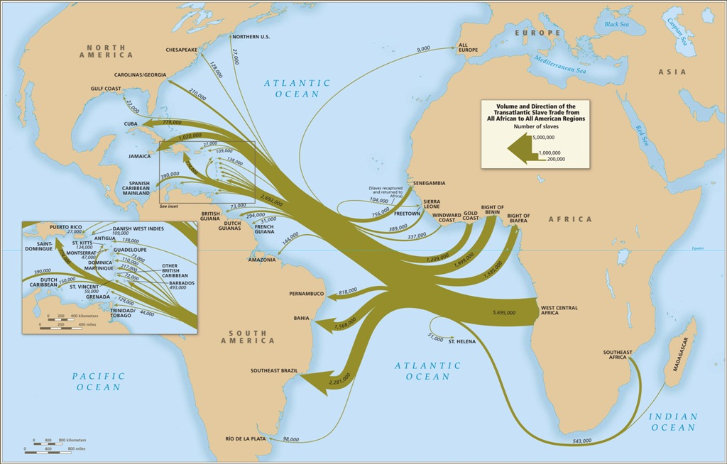

Image 2: Major Coastal Regions where slaves left Africa from https://www.slavevoyages.org/static/images/assessment/intro-maps/07.jpg
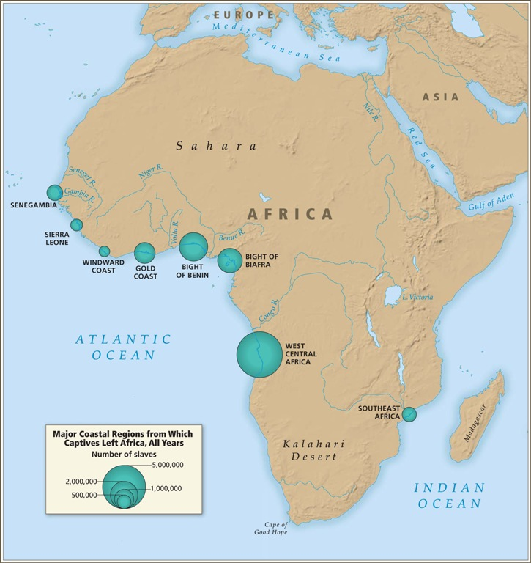
Image 3: Number of slaves transported from Africa between 1650 – 1860 to the Americas slave_trade_1650-1860_b-www.slaveryinamerica.org_3-1tl5xiw.jpg (600×351) (wpmucdn.com)
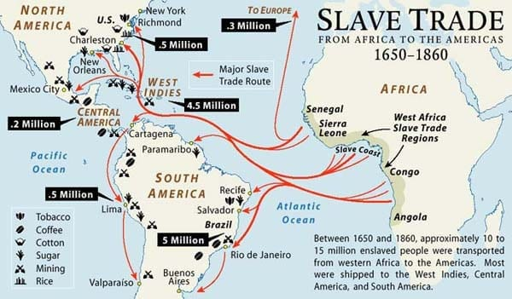
Image 4: The Middle Passage:
Remarks on the slave-trade ... Printed and sold by Samuel Wood, No. 362 Pearl-Street [1807]. | Library of Congress (loc.gov)
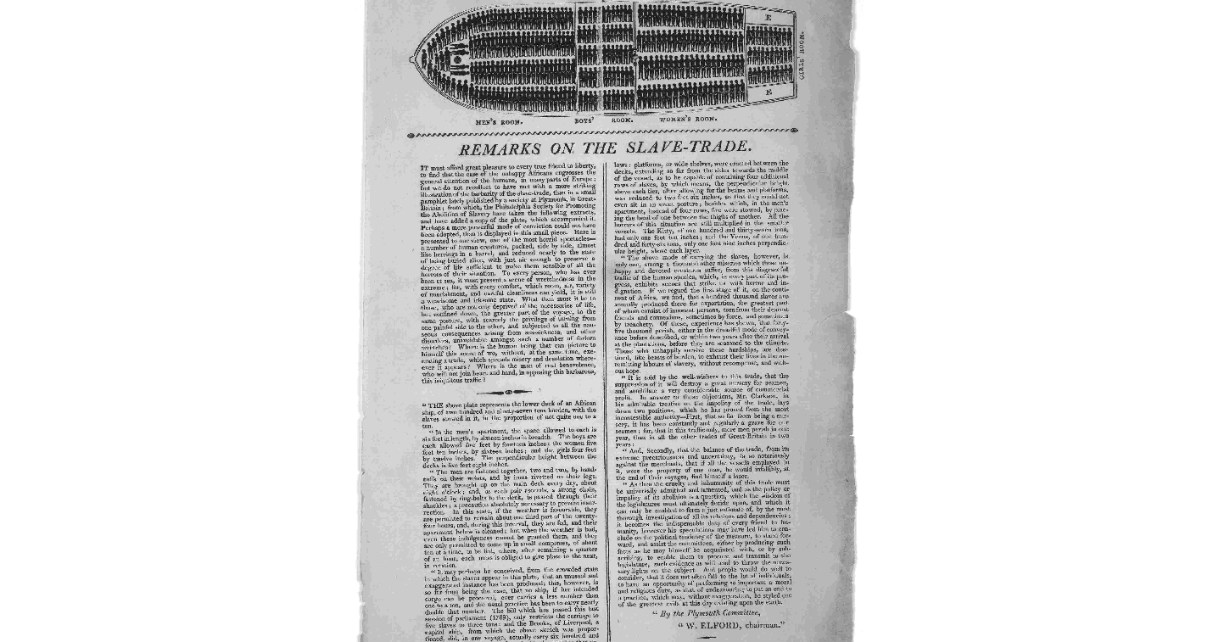

Active Learning Assignment
The Active Learning Assignment will be to compile LEARNING RESOURCES based on the syllabus weekly topic and course assignments requirements that can be added to by students (and other faculty). These learning resources will be housed or uploaded on CUNY Academy Commons website after the compilation by students and the instructor at the end of the Fall 2020 semester. Students will research appropriate learning resources pertaining to each week’s topic and compile information such as videos, articles, books, web links, from various sources. The learning resources that students will compile will be incorporated into the syllabus as “additional learning resources”.

Title: Africa and the Trans Atlantic Slave Trade – HIST 374

Link: https://hist374.commons.gc.cuny.edu/

Tag: An OER / ZTC (WI) Course at York College – Fall 2020.

Students will decide together in the course discussion thread the Creative Commons or CC license attributes. Students final presentation will be included in the resources that will be uploaded to the project page. All work independently or collaboratively done by students will be designated and protected with the following Creative Commons license attributes below.

Additional information on Creative Commons can be found here: https://creativecommons.org/about/cclicenses/
Midterm Exam: Outline, Introduction / Background of research paper
Keep in mind that the midterm in not simply a page of outlines but the outline you cross checked with me filled out with the appropriate info for each section. There is no specific minimum but under assumption that the intro section is to discuss in historical context the topic. The midterm should cover the background info of the discussion of your response paper. Review your previous course assignments especially the reflection papers and weekly course discussions om blackboard.
______________________________________________________________________________
Response / Reaction Paper: a 5 page double spaced response paper on the “Trans Atlantic Slave Trade and its impact on African societies and people of African Decent”.

The paper should be focused on an issue, event, or activity. It could be based on a thing [phenomenon] such as psychological implications or its after effect on black men, loss of self and identity, racism, racial oppression, economic or political problem, artificial borders and conflict, decolonization, colorism, African culture transplanted in the Americas, food culture, dress, hair, language, slangs, religion, spirituality, symbols, gestures, forms of expressions, music and so on. The response / reaction paper be to respond to or react to the selected topic and the impact that the selected topic has had in the lives of Africans or people of African descent. This paper will serve as the “body 2” section and will be incorporated into the final research paper content.

You have control over what you can write about from the effects of The Trans Atlantic Slave Trade on Africa, Africans and on people of African descent.

In addition to providing a regular reference page, you will need to compile a minimum of 10 annotated Bibliographies to support your work. These references will be used as part of the Active Learning OER / ZTC resources for the course project.

HIST 374 FINAL EXAM: The first part of the final exam will be a 10 – 15 pages written paper to meet the WI requirement for the course. The second part of the final exam will be a 10 – 15 pages PowerPoint (or story map) with a voice presentation summarizing contents of the final exam topic.

Part I: PAPER – 10 points

I have provided a tentative outline to help you with various sections of the paper. For example, you can easily insert sections of your previous assignments (that fit into the outline and intro sections), midterm, discussion questions, response paper. Of course you will make sure the sentences flow evenly as a ONE VOICE paper. When you write your outline, make sure that you include section headings on how the sections connect to each other sections.

Guiding questions for final paper and presentation
Final Exam Topic: “Africa, Africans and People of African Descent: re – examining human rights challenges 400 Years After The Trans Atlantic Slave Trade”.

1. Discuss the impact of the suffering of the Trans Atlantic slave trade on people of Africa and people of African Descent today. Include in your discussion examples of what some implications of this era that continues into the present day.

2. How can Africans and people of African Descent re - write their history to bring about more awareness on the events and implications of the Trans - Atlantic Slave Trade in many countries or communities today?
3. What are the future implications psychologically, economically, politically and emotionally in terms of broken relationships / linkages, identity loss / crisis which have plagued Africans and people of African Descent for centuries?
4. Discuss examples of Human Rights challenges and provide a justification for injustices based on standard International Human Rights principles.
5. How can you as a student of HIST 374 after this semester help in telling the story of your learning outcome in this course after this semester?

Suggestion: see week 15 / 16 folders on BB discussion folder for resources posted
Write recommendations, solutions, or suggestions based on everything that we have discussed throughout the semester. See your weeks 1 – 15 discussion responses, your reflection papers, your responses to your colleagues, your midterm ppt, your response paper discussion. Use references from the listed in week 15 folder in addition to your own researched references. This will be part of the summary you will write for your final exam when you combine your semester work together as a ONE VOICE PAPER. You will need both in text and separate reference pages including the 10 annotated bibliographies from your response paper.

Your paper final exam paper should be formatted as follows:
- Title page
- Outline page: content of your overall plan including section headings
- Intro: (if you want the optional IHRC certificate, you will need to add the relevance of your topic to HR in part of this section).
- Body 1: discuss revised midterm paper (provide a background or clearer intro on the “how”, “what”, “where”, “why”, “when” and “who” of the topic: Africa and The Trans Atlantic Slave Trade.
- Body 2: discuss revised response paper: address the ONE (or set of topics / issues: remember NOT everything that happened after section one is negative. For example, it provided in some places new search for language, identity, food, clothing, spiritual identity and so on)
- Body 3: provide a discussion / justification: this is the section where you provide a discussion (of human rights challenges / problems based on historical and current day injustices towards people of Africa, African Descent (if you want the optional IHRC certificate, you will need to add the relevance of your topic to HR in this section).
- Body 4: provide recommendations, suggestions or solutions to current day challenges – for example, what can be done, how can these be addressed? How can Africans and people of African Descent in the Diaspora build on the year of return making 400 years of the end of the Trans - Atlantic slave trade from 1619 – 2019? What is next for black people around the world? (if you want the optional IHRC certificate, you will need to add the relevance of your topic to HR in this section, This is the section to justify why human rights matter based on the HR lessons and how HR can be used in bridging everything that you have discussed in this paper especially on how to address current day societal injustices towards Africans and People of African descent 400 years after the 1st set of Africans set foot in Jamestown, VA).
- Conclusion: summarize your entire paper from intro to conclusion in this section.
- References: you will need a separate reference page to support all the sentences from intro to conclusion. See guidelines below.
- Annotated Bibliographies: you will need to include the 10 references that you used for the response paper.
Note that the title, reference and annotated reference pages are not part of the 10 - 15 written pages but separate.
GUIDELINES FOR FINAL EXAM PAPER
- APA or MLA, Times new Roman 12 point font. Double spaced.
- Make use of BOTH in text and separate reference page and cite accordingly. Utilize a minimum of 10 new references / resources in addition to the ones from your midterm and response papers.
- DO NOT COPY AND PASTE WEB LINKS AS REFERENCES. See the folder on BB on how to cite (for example, use author, date, article title, publication title etc and not just weblinks such as www.history.com). Make use of periodicals. If you get info from a webpage, make sure you cite appropriately.
- Include all references from the beginning of the paper to the end on a separate reference page in addition to your 10 annotated bibliographies from your initial response paper.
- DO NOT copy and paste sentences or paragraphs. Make sure to put in quotations, summarize, paraphrase and use your own words. See the writing center (online help) if you need help with your papers or the folders on the BB page on writing.
- The initial PPT point presentation should be posted to the week 15 discussion forum for others to comment and provide feedback. POST YOUR PAPER ONLY TO THE ASSIGNMENT FOLDER.
- The FINAL PAPER is due by Sunday December 15th by 11:30PM. Post in BB assignment folder under Final Exam.
- PLEASE PLAN AHEAD. NO “INC GRADE” OFFERED FOR THE COURSE.
- Final grades for the course will be posted on Wednesday December 18th to the registrar.

Part 2: Powerpoint Presentation – 10 points
You will need to create a ppt or story map for the final exam. You can create a 10 - 15 pages ppt slides for each page of your research paper and provide a 10 – 15 minutes voice explanation of your paper. Be creative with this presentation.

GUIDELINES FOR PPT
- Create a 10 - 15 page PPT presentation of your of your final paper.
- Feel free to make use of images, maps, graphs, timelines. Make sure that each item are labelled appropriately on each slide and you justify the use with clear explanation.
- The title, summary and reference pages are NOT part of the minimum of a 15 PPT slide pages including the minimum of 12 - 15 minutes voice over summary of the presentation (you are welcome to do a story map presentation if you feel comfortable doing one otherwise a ppt and voice summary is fine). You can do more than 15 ppt slides and more than 12 – 15 minutes voice summary.
- Make sure that you have adequate notes to your presentation at the bottom explaining your responses discussion (as you would as if making a live presentation in front of an audience).
- My suggestion is that for the topics covered in this class, you should all opt for the IHRC certificate and recognition. This would be a nice take away for your participation in this course this semester. You will have to do minimal work since you will be responding to a topic based on injustices and most of that discussion, you have covered in your midterm and response papers. You can “tweak the sections of your paper” to include relevance to human rights and make a justification for it in your midterm, response papers and the final sections on recommendation, suggestions or solution. Discuss Human Rights challenges or views based as part of the justification of Africa, Africans and People of African Descent: 400 Years After the Trans-Atlantic Slavery.

International Human Rights Commission (IHRC) Recognition / Certificate
Based on the syllabus / WI course requirement for HIST 374 on “Africa and the Trans Atlantic Slave Trade” and on the OER / ZTC learning resources on Africa, Africans and People of African Descent 400 years during and after the Trans Atlantic Slave Trade, after re - examining current human rights challenges as learned during course discussions about the many social, economic and political injustices that have been systematically rooted as part of the day to day societal fabric in many parts of the Americas, students will identify, discuss, expand upon and provide recommendations in their final exam written papers and oral presentation on eliminating current day human rights injustices towards Africans and People of African Descent.
After incorporating elements of international human rights standards and principles in their final exam content and fulfilling the course WI requirements, all students will receive a recognition and a certificate from the International Human Rights Commission (IHRC) as part of a pilot program on Human Rights education. A commemorative online event will be hosted by IHRC after the end of the semester in which students will be recognized and presented with a certificate for their efforts throughout the HIST 374 course by the Secretary General of the IHRC. Students will be invited to future IHRC activities and events after the covid lockdown when the United Nations returns back to its normal session.

Course and Instructor Policies on attendance, participation, fieldwork, communication protocols including response time / due dates:
- Good attendance is required as good results are the result of effort expended in the aggressive pursuit of knowledge. Good attendance encourages participation in course discussions.
- Punctuality is to be expected as lateness is disrespectful to the instructor, fellow students and the learning process in general. Leaving early and constant trips outside while the class is in session are discouraged and will result in lowering of grades.
- Plagiarism or cheating will not be tolerated and result in an “F” in the class. Plagiarism will not be tolerated and is an automatic “F” on the paper and in this class.
- Concentration should be focused only on the class. All cellular phones and other electronic devices must be turned off. No social conversation should take place during class, only class related discussion is allowed.
- Any student in need of special accommodations due to health-related challenges should contact the instructor immediately so that special provisions may be arranged. Issues of this type should have proper official documentation from certified authorities.
- Summarize the day’s reading and the class will then participate in a discussion on the readings. Two different postings two different times per week to 2 two different people in addition to the responses to the main questions posted by the instructor.
- Netiquette is very essential in an online class. Students will adhere to York College policies for appropriate student conduct and behavior when on zoom or BB collaborate lectures. There will be no profanity or obscenity whenever students are live on zoom or BB collaborate lectures. Students will conduct themselves appropriately when posting comments or responding to the instructor or to other students on BB discussion forums.
- Final Exam due are: The written final exam paper and oral presentation is due on THE LAST DAY OF THE FINAL EXAMS as designated on the YORK COLLEGE Final Examination calendar. Papers may be submitted earlier upon completion and students are welcome and encouraged to send draft papers to the instructor for review and feedback ahead of the final exam due date. Papers received after the due date will be penalized by one grade letter.

- No INC – incomplete grade will be offered in this course, Plan ahead: All discussion questions and assignment information are posted on BB ahead of time.

Please consult the York College website and familiarize yourself with the following sections
York College and CUNY Policies: Policy on Academic Integrity, Policy on ABS / INC grades, Policy on accommodations for disabled students.
Student Support Resources
Tutoring Centers, IT support, Blackboard and Technologies support, Library Reference Desk https://www.york.cuny.edu/student-development/policies-and-procedures
*NOTE: Syllabus Tentative and Subject to Change

We will review the project description as we go along throughout the semester. All reading contents, resources, notes and learning materials are posted in the weekly discussion thread folders. As this is a WI course, students are required to conduct their own independent research based on the weekly discussion and then post their responses on the discussion thread with additional researched references which students can build on for the active learning assignment portion of the course requirement. Keep in mind that this syllabus is tentative and subject to change. At the instructors discretion, contents may be added to the syllabus or removed from it at anytime. Students will be notified of any changes as early as possible.
The learning resources that have been compiled in this syllabus and poste on the course Black Board discussion page are “suggested resources only” and provided as an ongoing effort to provide course students with select OER / ZTC materials. Students are encouraged to conduct their own active learning research for resources. If there are resources pertaining to the learning needs of this course that you would like to recommend for this OER / ZTC project, please contact the instructor to review and add them to the syllabus.
This OER / ZTC syllabus content will be reviewed and revised from time to time. Contents will be added to it or removed as part of the ongoing OER / ZTC project goals.

